DR. AMBEDKAR COLLEGE, DEEKSHA BHOOMI, NAGPUR

Date: 27th April 2019
Name of the Programme: Celebration of World Intellectual Property Day
Talk on “Career opportunities in Intellectual Property law”
Name of the Speaker: Ms Shilpa Rathod
Name of Program Co-ordinator: Ms Shilpa Rathod
Number of Participants: 64 (LLB VI Sem 3 Yrs & LLB X Sem 5 Years)
Name of Venue: Department of Law, Dr. Ambedkar College Deeksha Bhoomi, Nagpur

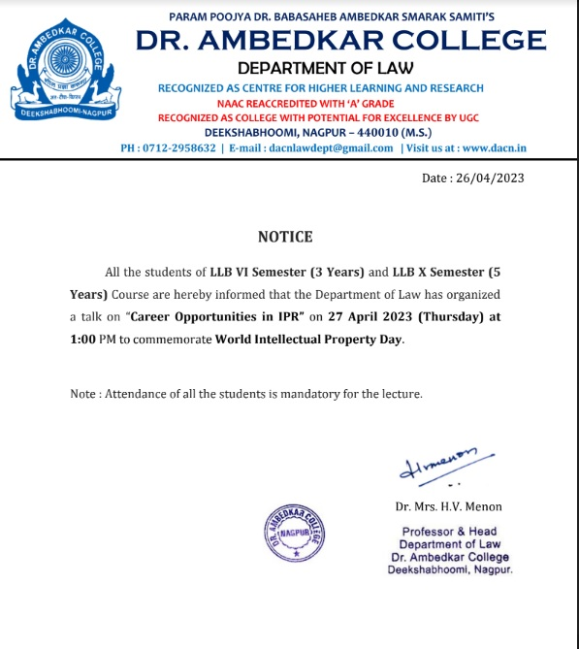

REPORT ON CELEBRATION OF “WORLD IP DAY” ON 26 APRIL 2023

The Department of Law, of Dr. Ambedkar College, Deekshabhoomi Nagpur, Celebrated 21st “World Intellectual Property Day” on 26, April 2021. The program was organized by the Department of Law.

The program commenced with the introductory remark on the primary objectives behind celebrating “World Intellectual Property Day” throughout the globe delivered by Head of the Department Dr. H.V. Menon.

It was followed with the lecture on the topic “Career opportunities in Intellectual Property law” by the faculty of law Ms Shilpa Rathod. She enlightened the students regarding different avenues under IP domain after passing law. She discussed that in the field of Patents, lot of positions are available for the students with technical background and without technical background. She further elaborated the avenues namely Patent Attorney, Patent Advisor and Consultant, Patent Examiner. She has further motivated the students towards Paralegal services and Litigation part for all IPR as the alternative field available to students after passing law.

She has empathetically provided the details of top-notch IP firms in India and discussed their working pattern. The special light has been thrown on the current theme of WIPO for this year which is “Women and IP: Creativity and Innovation”. She has specifically mentioned that this program helped in fulfilling the primary object of WIPO in raise awareness of how IP filed is booming in the current scenario.

Total 64 participants were present in the programme. The Programme was compared, conducted and concluded by proposing vote of thanks by Ms. Shilpa Rathod under the guidance & supervision of Dr.Mrs. H.V. Menon Professor and Head of Department.

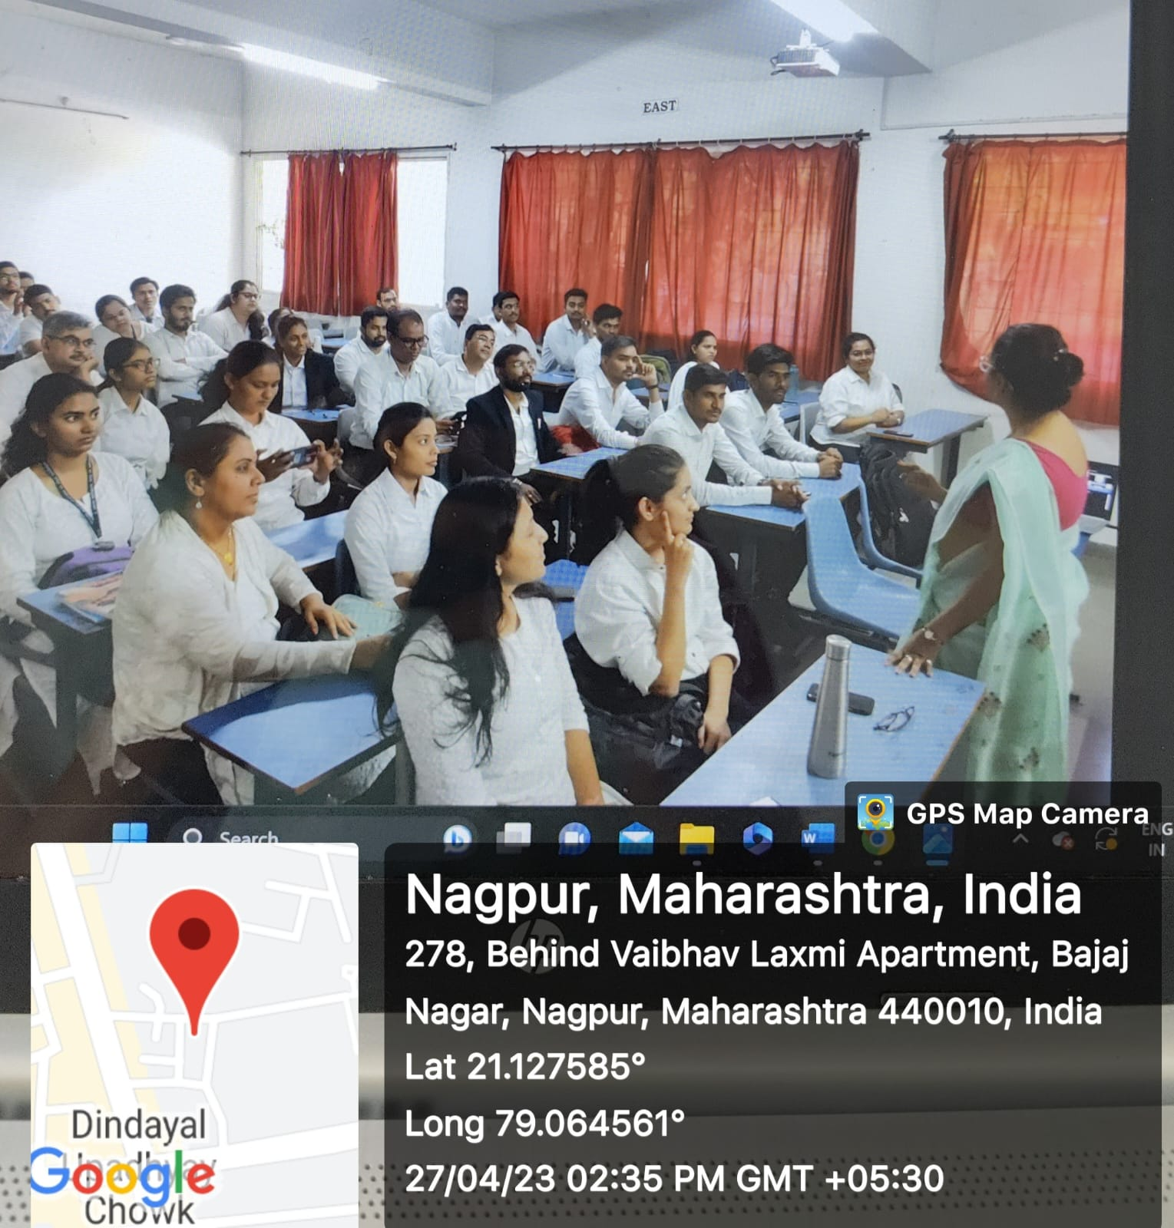 (Ms Shilpa Rathod delivering the lecture on “Career opportunities in Intellectual Property law” on the occasion of World IP Day)
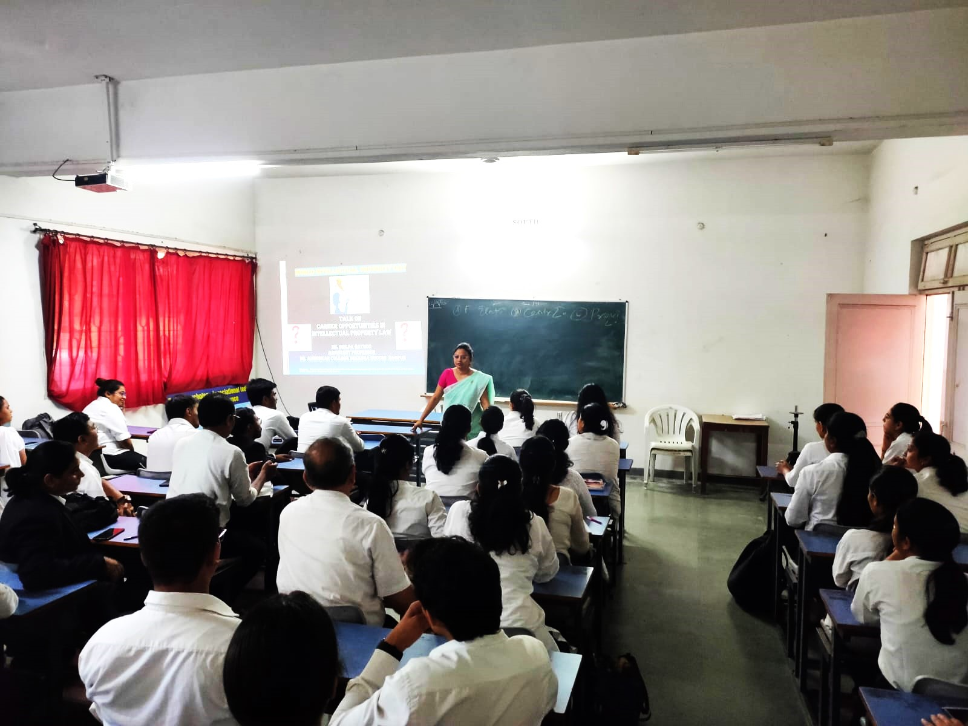
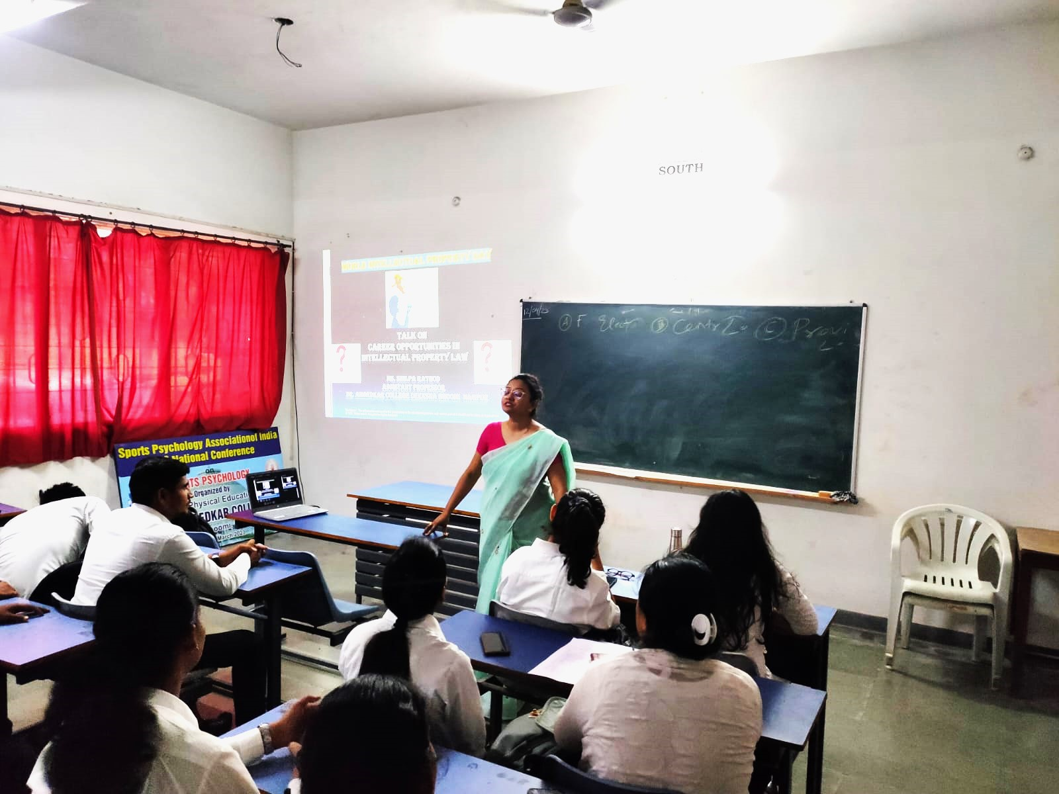

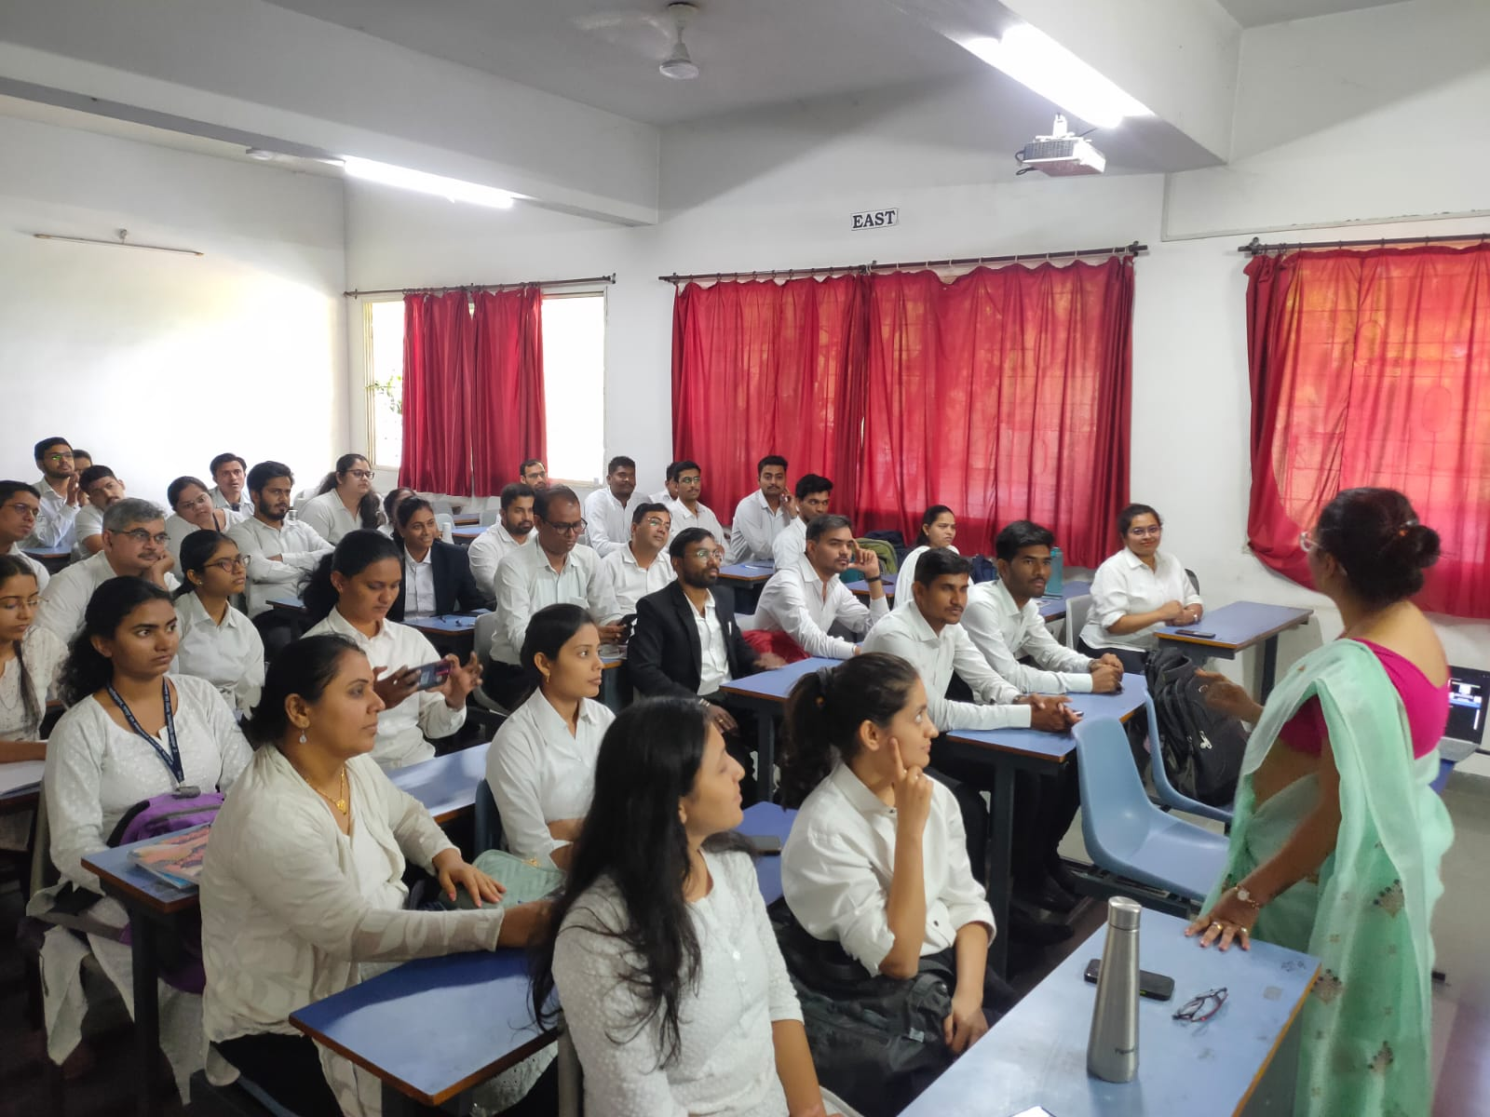

ATTENDANCE LIST OF THE PARTICIPANTS
(LLB VI Sem 3 years and LLB X Sem 5 years)
